Lab 1 - CS2506 – Alexander Stradnic – 119377263
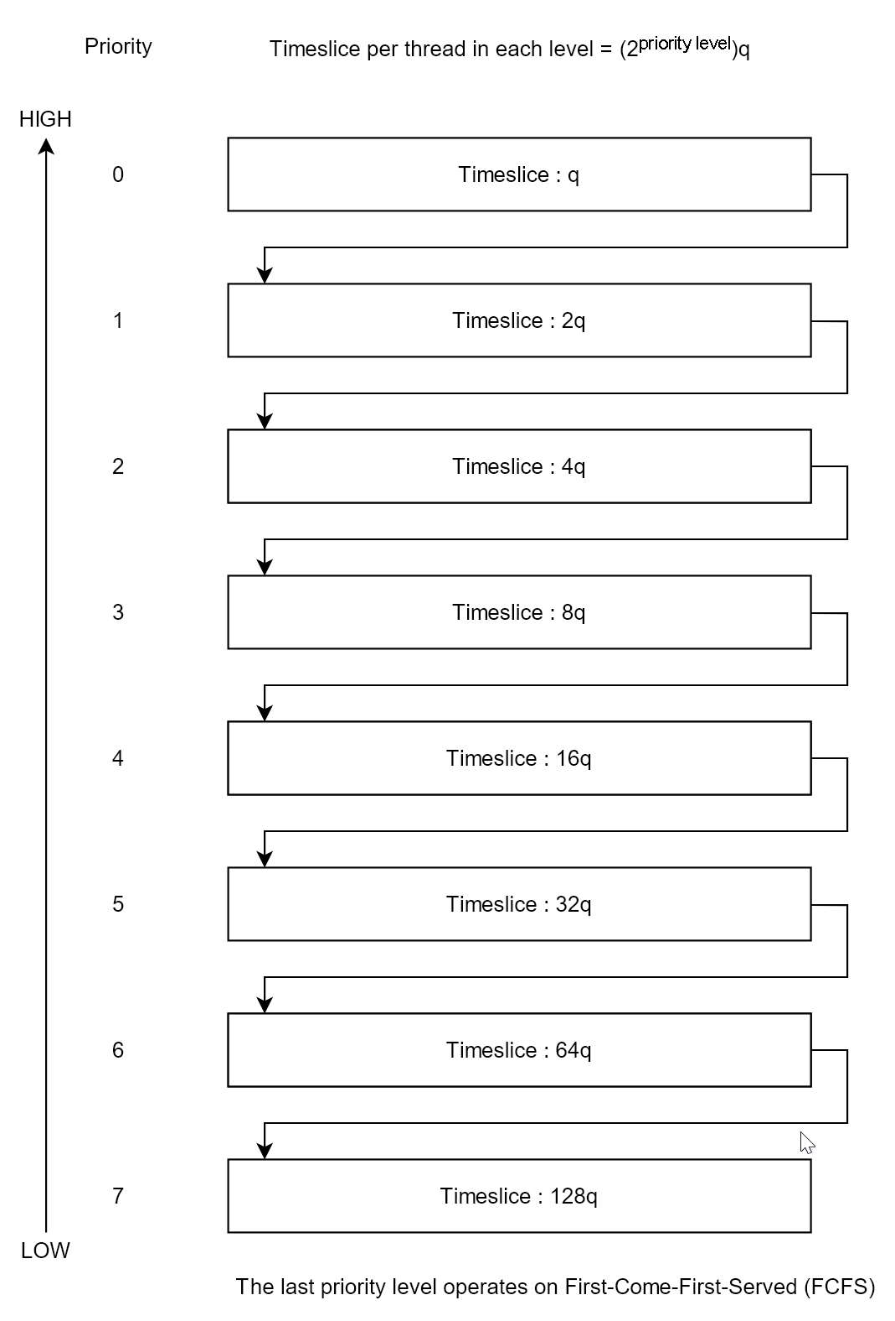
Task 1

If q = 1 for 1GHz, then q = 1.25 when the frequency is reduced to 800MHz.

When there are no user processes left to execute the system runs the Idle Process which is always the lowest priority process.

Task 2

while system.running:
|
while queues is empty and blocked_queue is empty:
execute(idle_process, idle_process.time_slice) // if the queues are empty, run the idle process. it has the lowest priority of any process

for queue in queues:
for process in queue:
if process.state == blocked:
move(process, queues[process.priority-1]) // if the process is blocked, move it up a level
else if process.state == ready:
execute(process, queue.time_slice) // execute the process for (2^{process.priority})q
if process.state == ready:
move(process, queues[process.priority+1]) // if the process is still not finished after being executed for the duration of its time slice, move the process down one level

for process in blocked_queue:
if not process.blocked:
move(process, queues[process.priority-1])

function execute(process, time_slice):
while time_slice > 0:
exec(process)

